

Lab 4

Lab Report on CSE 1204

**Submitted by Submitted to**

**Name**: Md. Shabir Khan Akash. Shyla Afroge Madam

**Class**: 1st year, even semester. Assistant Professor

**Dept**.: Department of CSE. Department of CSE, RUET

**Roll**: 1603108

**Section:** B

**Theory**

***Inheritance*** is the process by which one object can acquire the properties of another specifically, an object can inherit a general set of to properties to which it can add those features that are specific only to itself. Inheritance is important because it allows an object to support the concept of *hierarchical classification*. So. Inheritance certainly plays a very important role in OOP.

**Code**

**(With constructor)**

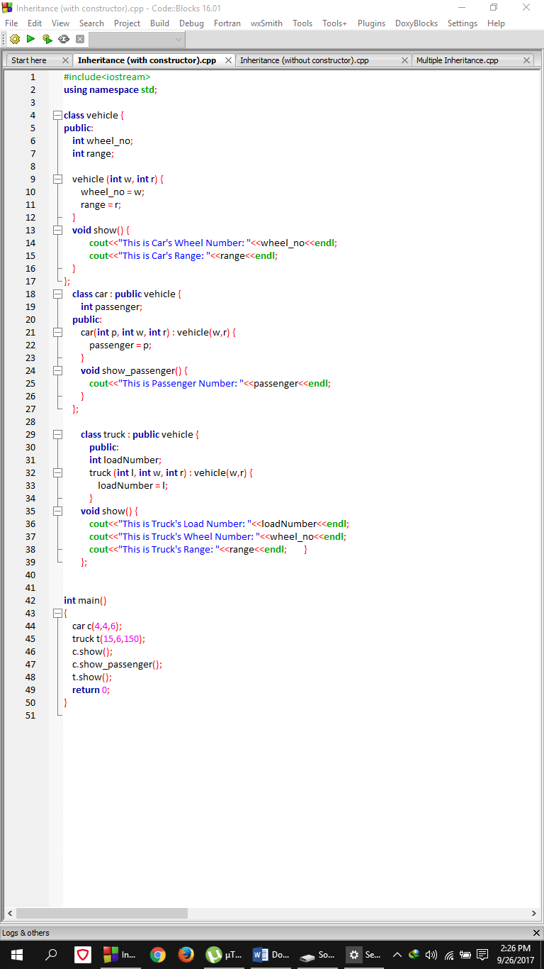

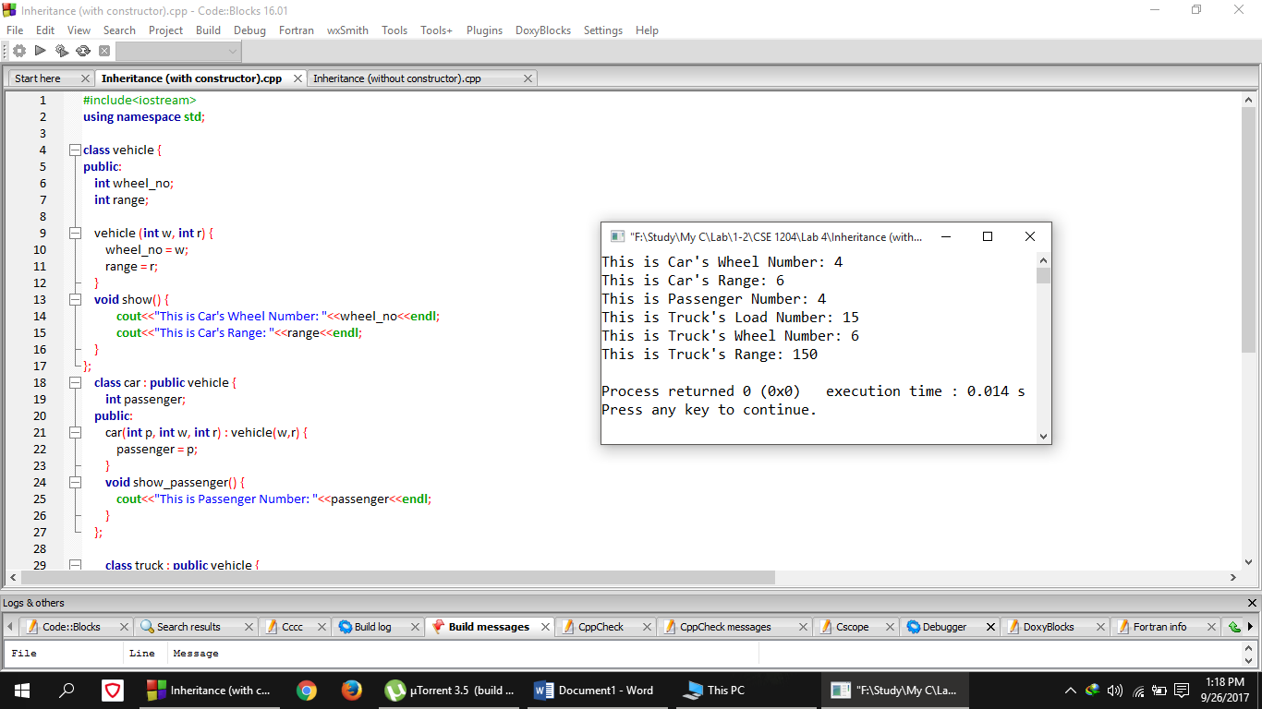**Output**

**Comment**

In this above code, a class named ***vehicle*** was declared where two integer variables ***wheel_no,*** and ***range*** was declared in public and also a constructor was declared to take the values of the two above variable from the initializing object. After that, a derived class of ***vehicle*** class, named ***car*** was declared where a constructor was declared to get the ***passenger*** number of the car. As it was derived from class ***vehicle*** so it has the access to the member of ***vehicle*** class. Then another derived class of ***vehicle*** was declared and it was ***truck*** where another constructor was declared to get the ***loadNumber*** of the ***truck.*** Finally in the main function, a ***car*** type object ***c*** and a ***truck*** type object ***t*** was declared and also initialized with values. Then the ***show()*** function was called for both ***car*** and ***truck*** class and ***show_passenger()*** was called to show the number of passenger.

**Code**

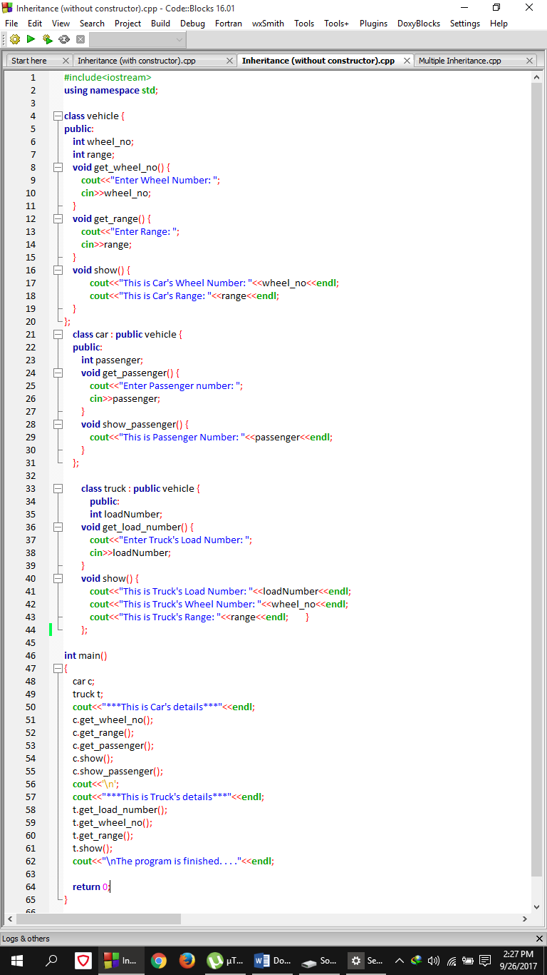**(Without Constructor)**

**Output**

**Comment**

In this above code, a class named ***vehicle*** was declared where two integer variables ***wheel_no,*** and ***range*** was declared in public and two functions ***get_wheel_no()*** and ***get_range()*** was declared to take the values of the two above variable for the object. After that, a derived class of ***vehicle*** class, named ***car*** was declared where two functions ***get_passenger()*** and ***show_passenger()*** was declared to get the passenger number of the car from the console and show the passenger number respectively. As it was derived from class ***vehicle*** so it has the access to the member of ***vehicle*** class. Then another derived class of ***vehicle*** was declared and it was ***truck*** where a function ***get_loadNumber()*** was declared to get the ***loadNumber*** of the ***truck*** from the console***.*** Then ***show()*** function was declared to show the wheel number, range and load-number of the truck.Finally in the main function, a ***car*** type object ***c*** and a ***truck*** type object ***t*** was declared and also initialized with values. Then all thefunctions were called for both ***car*** and ***truck*** class to show the above output.

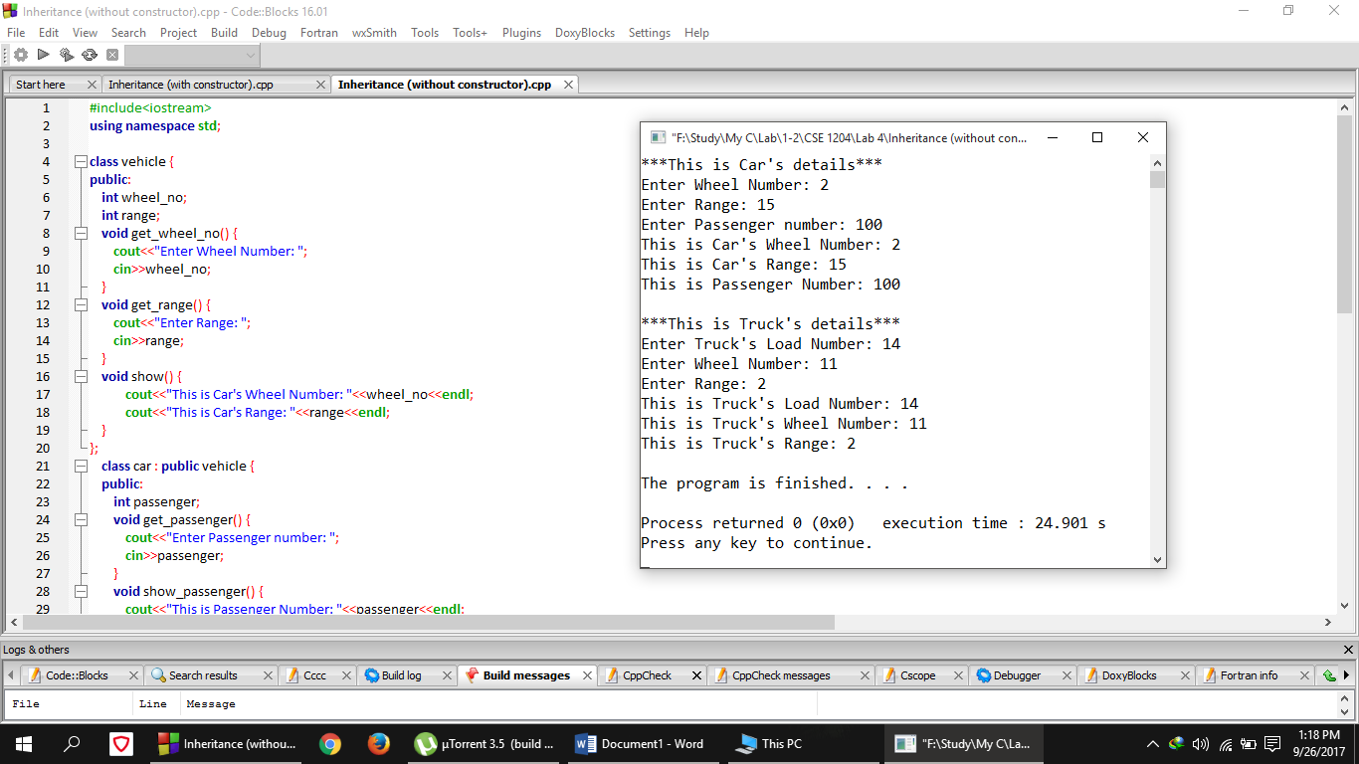

**Code**

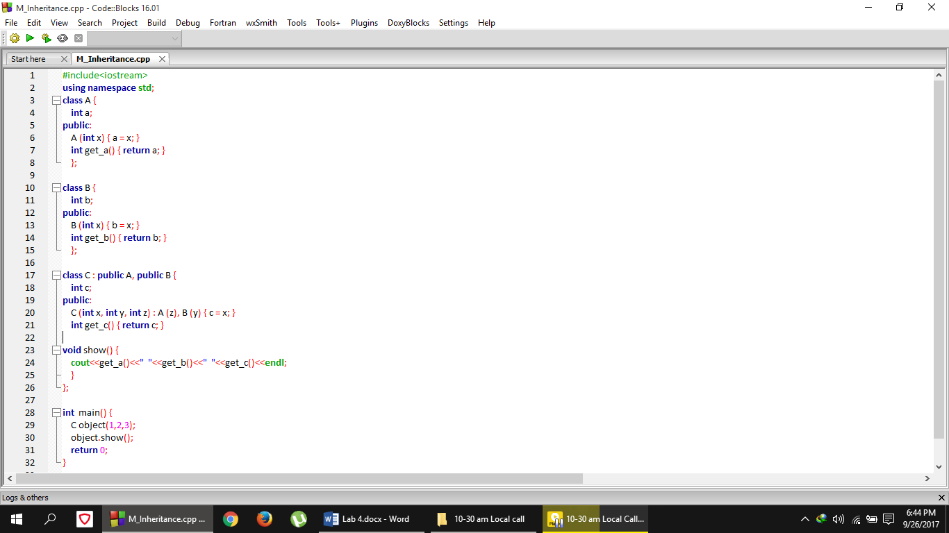**(Multiple Inheritance)**

**Output**

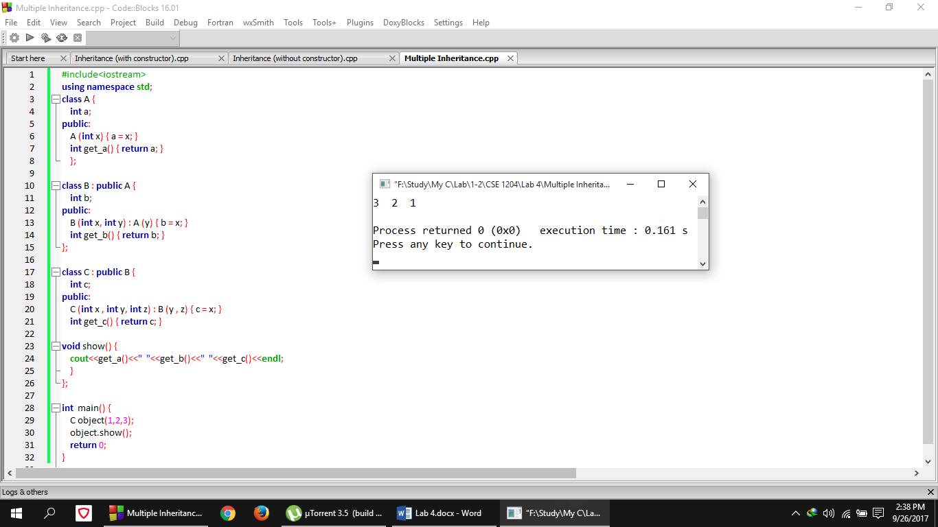

**Comment**

In the above code two parent classes ***A*** and ***B*** were declared where two functions ***get_a(), get_b()*** were declared in each of the classes to get the value of a and b. Then another class ***C*** derived from both **A** and **B** was declared and a constructor was declared in that class to get the access to the private member of the parent classes. After that declaring a class ***C*** type object ***object*** with initialization and calling the ***show()*** function in the main function, the above output was found.